# РОССИЙСКИЙ УНИВЕРСИТЕТ ДРУЖБЫ НАРОДОВ

**Факультет физико-математических и естественных наук Кафедра прикладной информатики и теории вероятностей**

**ОТЧЕТ**

**ПО ЛАБОРАТОРНОЙ РАБОТЕ**

**№ 2**

*дисциплина: Операционные системы*

## Студент:

Джеффри Родригес Сантос

## Группа:

НПМбд-02-20

**МОСКВА**

2020 г.

Указания к лабораторной работе Система контроля версий Git представляет собой набор программ командной строки. Доступ к ним можно получить из терминала посредством ввода команды git с различными опциями.

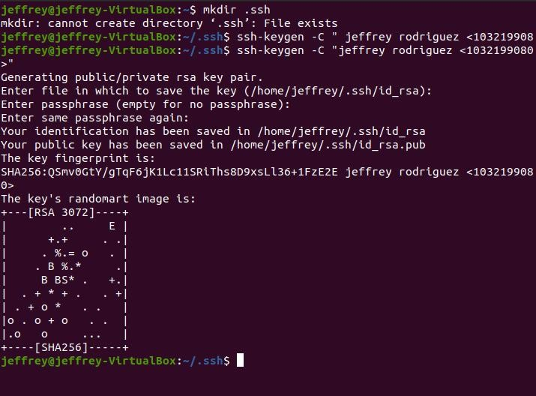

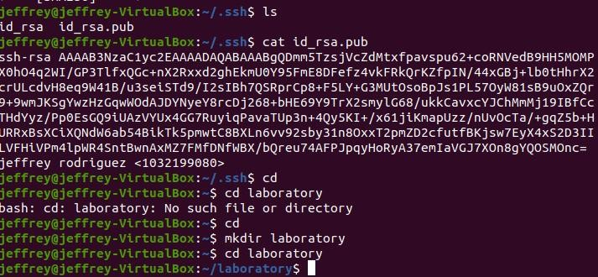





Initialized empty Git repository in /home/jeffrey/laboratory/.9it/

$ echo " # 1 abo r ato r y nor ks # ” > README .

S git add README.md

$ git status

9n branch master

9o commits yet

han9es to be comnitted:

( use " g tt r n - - cached <ftter .. . " to uns tag e)



$ cd

: $ nkdir laboratory

$ cd laboratory

Conn and

not found , but c an be ins ta1ted wtth:

apt tn stall git

$ sudo apt install git

[ s udo] passuo rd for jeffr ey:

Readt • 9 package It sts . . . Done Building dependency tr ee

Reading state tnfornatton . . . Done

The fol toutnp additional pac kages uttt be tns tailed: 9*‹- nan ttber for - per I

*Sn* gges ted packages :

get - daenon - r un | gtt - daenon - s ys vtntt ptt - doc pt I - ed ptt - enatl g+‹ - 9^* §ttk gttxeb gtt - cv s gtt - ned tauTkt gtt - svn

The following NEW packages rift be tns tailed :

9it git-man liberror-perl

0 upgraded, 3 newly installed, 0 to remove and 126 not upgraded. Need to pet 5 468 kB of archives.

After this operation, 38,4 MB of additional disk space will be used. Do you want to continue? {Y/n] y

Get:1 <http://ru.archive.Ubuntu.com/ubuntu>focal/main amd64 liberror -perl all 0. 17029-1 [26,s kB]

let:2 <http://ru.archive.ubuntu.com/ubuntu>focal-updates/main amd64 9it-man all

S git config --global user.name ”jeffrey

$ git config --global user.email “jeffre

y 1780ghotnat1 . con”

S git commit -n ”first commit" [naster (root-commit) dl3c39e] first conmit

1 file changed, 1 insertion(+) create node 100644 README.md

$ git push -v ori9in master 9<*09#thub.com: Permission denied (publickey).

fatal: Could not read fron remote repository.

Please make sure you have the correct access rights and the repository exists.

$ wget https://creativecommons.orq/licen

ses/by/4.0/legalcode.txt

--202i-05-01 22:50:06- - https://creativecommons.orp/licenses/by/4.0/legalcode. txt

Resolving c reattveconnons . or g ( cr eattveconnons . o r g) . . . 104.20 . 150 . 16, 104 . 20 . 15

1.16, 172.67.34.140, ...

Connecting to creativeconnons.org (creativecommons.org)|104.20.150.i6|:443... c onnected.

HTTP r eques t sent , awatttng r es ponse .. . 200 OK

Length: Ans pectfted [text/ p\.atn] Savtng to: ’ tegatcode . txt’

legalcode . txt

[ <=>

] 18, 22K - - . - KB / s

in 0s

202i-05-01 22:50:07 (96,3 MB/s) - 'legalcode.txt’ saved [18657]

$ sudo apt install curl



[sudo] password for jeffrey: Reading package lists... Done Building dependency tree

Reading state infornation... Done

The following NEN packages xttt be installed:

0 upgraded, 1 newly installed, 0 to remove and 8T not ° P9'aded. Need to get 161 kB of archives.

After this operation, 411 kB of additional disk space will be used.

let:1 <http://ru.archive.ubuntu.com/ubuntu>focal-updates/main amd64 curl amd64 7

.68.0-iubuntu2.5 [i61 kB]

Fetched 161 kB tn 1s ( 136 kB/ s)

Selecting pr evtous ty uns elected packag e cur I .

( Read Eng database . . . 184001 Ities and dt r ector tes cur r entry installed .) Prepar Ing to unpack . . / c ur 1 7. 68. 0 - 1 ubun tu 2 . 5 and64. deb

Unpa cktng cur I ( 7. 68. 0 - 1ubun tu 2 5) ...

Setting up cur I ( 7. 68. 0 - 1 ubun tu 2 . 5)

P r ocess tng I r t r 9er s fo r nan - db ( 2. 9. 1 - 1 } . . .

$ cvr I - L - s https: / /uuu . gI t I gno r e. to/ ap

1c,lc-bitrix,a-frame,actionscript,ada adobe,advancedinstaller,adventureqamestudio,a9da,al alteraQuartusii,altium,amplify,android,androidstudio an9ular,anjuta,ansible,apachecordova,apachehadoop appbuilder,appceleratortitanitm,appcode,appcode+all,appcode+iml appen9ine,aptanastudio,arcanist,archive,archives xcodeinjection,Kilinx,xilinxise,xilinxvivado,xill xojo,xteKt,y86,yarn,yeoman

yii,yii2,zendframework,zephir,zig zsh,zukencr8000

[naster 78e05c}] second comnit

1 file changed, 396 insertions(+) create mode 100644 legalcode.txt

naster 78e0 5c 1] second connt I

1 ft\.e chang ed , 396 ins e r tions ( +} c r eate node 100644 tegatcode . txt

$ git add .

$ g1t c omtt - an ” second connt t "

$ git add .

$ 9it conmit -an “second comnit"

Не следует путать с GitHub - веб-сайтом для размещения git- репозиториев и совместного разрабоетки провро.

Не следует путать с GitLab - веб-сайтом для размещения git- репозиториев и совместный разрабоетки провро.

